**Servo motor** with a **potentiometer** using an **Arduino Uno**

**Aim:**

To control a **servo motor** with a **potentiometer** using an **Arduino Uno**

**Components:**

* Arduino Uno
* Servo motor (e.g., SG90 or any standard RC servo)
* Potentiometer (10kΩ works fine)
* Jumper wires
* Breadboard (optional)

**Circuit Connections:**

1. Servo Motor:
   * GND (Ground): Connect to Arduino GND.
   * VCC (Power): Connect to Arduino 5V.
   * Signal Pin: Connect to Arduino pin 9 (or any other PWM-capable pin).
2. Potentiometer:
   * One outer pin: Connect to 5V on Arduino.
   * Other outer pin: Connect to GND on Arduino.
   * Middle pin (wiper): Connect to Arduino A0 (analog input).

Code:

#include <Servo.h> // Include the Servo library

Servo myServo; // Create a servo object

int potPin = A0; // Pin connected to the potentiometer

int servoPin = 9; // Pin connected to the servo motor

int potValue; // Variable to store the potentiometer value

int servoAngle; // Variable to store the servo angle (0-180 degrees)

void setup() {

myServo.attach(servoPin); // Attach the servo to pin 9

Serial.begin(9600); // Begin serial communication for debugging (optional)

}

void loop() {

potValue = analogRead(potPin); // Read the potentiometer value (0-1023)

servoAngle = map(potValue, 0, 1023, 0, 180); // Map the value to a range of 0-180 degrees

myServo.write(servoAngle); // Set the servo position

Serial.print("Potentiometer Value: ");

Serial.print(potValue);

Serial.print(" -> Servo Angle: ");

Serial.println(servoAngle);

delay(15); // Short delay to allow the servo to reach the desired position

}

Circuit Diagram:

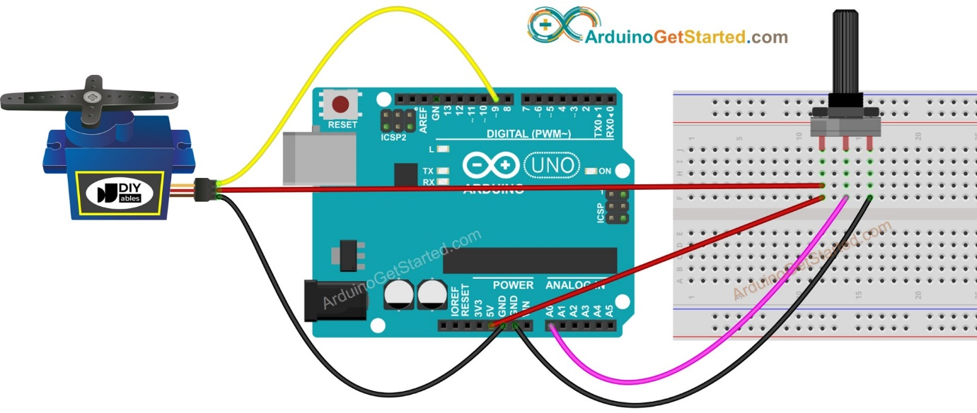

**Explanation:**

* **analogRead(potPin)** reads the potentiometer value (from 0 to 1023).
* **map()** function converts the potentiometer value to a servo angle (from 0 to 180 degrees).
* **myServo.write(servoAngle)** moves the servo to the corresponding angle based on the potentiometer value.

Upload the code to your Arduino, and as you turn the potentiometer, the servo motor will rotate accordingly.